
Assistant Professor Amber Graeber, Ph.D.
Drake University School of Education | 2700 Forest Ave Des Moines, IA 50311
Leadership Preparation Program
Clinical Handbook

Clinical Experience Description
The clinical experience is captured in two, two semester-long classes where students are required to complete a total of 200 hours per year. Students will earn 125 hours per year through clinical experiences with practicing school leaders, while course assigned field-based learning experiences will account for 75 hours per year.
Because students will be certified as K-12 school administrators, students must complete one clinical experience at the PreK/elementary level and one at the secondary level. To ensure students have a wide variety of experiences and opportunities, and to learn from different settings, as a general rule, no more than half of the student’s time may be spent in their own district.
Students develop a Clinical Learning Plan before beginning each experience (EDL 280, EDL 281). The Clinical Learning Plan includes the student’s professional platform, leadership standards they plan to address, learning goals they need to accomplish, and action steps designed to reach those goals. The clinical learning plans are approved by the clinical professor and are shared with the mentor by the students at the start of each experience. They are meant to be a guide and are flexible to allow the mentor and student to collaborate and design appropriate learning activities to fit specific situations. For further details about the clinical experience (Appendix A) or Drake’s Master of Education Principal Preparation (Appendix B), please refer to the appendix for the syllabus and program description.

Mentor Roles
Mentors are selected in a collaborative manner between the clinical professor and student and play a vital role in the preparation and development of the students for entry-level administrative positions. Mentors will be a role model, a resource, and an essential positive influence for students in their Clinical Experience.

Mentor Responsibilities
- Reach out, when needed, with the clinical professor to learn about the program and expectations and to have any questions answered (Appendix A).
- Skim the overview of Drake’s Educational Leadership Program (Appendix B).
- Sign and return Mentor Contract (Appendix C).
- Review and discuss the student’s Clinical Learning Plan (Appendix D) paying particular attention to activities students can complete with the mentor (Appendices E, F).
- Commit the time necessary to plan for, provide, and support authentic learning experiences for students.
- Engage in feedback with the student to support their learning (Appendices G, H).
- Share with the clinical professor via telephone, e-mail, or face-to-face summative evaluation comments (Appendices G, H).

Student Responsibilities
Be prepared for the clinical experience by successfully completing the course work, Field-Based Learning Experiences, standards reflections for the portfolio, and self-assessment of achievement in course objectives.
- Work with the clinical professor before beginning each of the clinical experiences.
- Submit a completed mentor contract each year (Appendix C).
- Create and submit a Clinical Learning Plan for approval by the clinical professor before meeting with the mentor in Clinical I (EDL 280) and a revised Clinical Learning Plan with new and/or additional goals before meeting with the mentor in Clinical II (EDL 281) (Appendices A, D).
- Submit assignments when due unless alternative arrangements are made in advance with the clinical professor.
- Submit a minimum of three reflective journals per clinical to the clinical professor during both clinical experiences (Appendix A).
- Report approximate hours and experiences with each reflective journal submission (Appendix D).
- Submit a synthesis of the experience to the clinical professor.
- Participate in the one-day, in-person learning seminar for each clinical (two summers).

Clinical Professor Responsibilities
- Work with students in creating the Clinical Learning Plan (Appendices A, D, E, F).
- Provide feedback on “experience journal” reflections and professional notes from students (Appendices A, D).
- Coordinate mentor/student placements (Appendix C).
- Collect and file signed mentor contracts (Appendix C).
- Maintain contact with mentors for formative evaluation discussions as needed during the semester (Appendices G, H).
- Complete an assessment of student accomplishment of the course objectives and submit to the program faculty for inclusion in the program assessment database.
- Collect student and mentor evaluations (Appendix H).
- Prepare and facilitate clinical learning seminars.

Program Audience
This program has been designed for students aspiring to be:

- Principals
- Associate/assistant principals
- Curriculum coordinators
- Deans of students
- Teacher leaders
- Athletic directors
- Area Education Agency consultants
- Department of Education consultants

Program Graduate
As a new administrator, the Drake graduate in Educational Leadership will demonstrate:

- Readiness for leadership.
- Commitment to students and their learning.
- Intellectual curiosity and scholarship.
- Commitment to the professional development of adults.
- Commitment to ongoing learning.

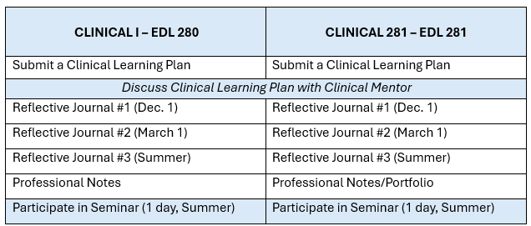

APPENDIX A – CLINICAL OVERVIEW

Clinical experiences are designed to integrate students’ learning from course work, the standards, and field-based learning. Students will work in educational and other approved settings with selected mentors. The clinical courses will be authentic experiences structured and guided at the individual student’s mentor sites. Faculty will function as facilitators of learning and support student needs as the experience proceeds. E-mail, phone, and (when possible and appropriate) face-to-face contact will be an integral component of the clinical experience.

Throughout the clinical experience, students will engage in the following:
- Connecting the goals of the Clinical Learning Plan to clinical opportunities.
- Synthesizing course work, standards, Field-Based Learning Experiences through clinical experience.
- Addressing all the standards through clinical experience.
- Communicate effectively with mentors.

Course Outcomes
By the end of the course, the successful student will be able to:
- Connect theory and practice during the clinical experience.
- Provide evidence of growth in knowledge and application of standards in real settings.
- Articulate the responsibilities, challenges, and positive aspects of being a school leader.
The State of Iowa requirement for clinical experiences is 400 hours.
125 hours – Clinical I (EDL 280)
125 hours – Clinical II (EDL 281)
150 hours – FBLEs *15 hours average for each Field Based Learning Project (10 courses x 15 hours), you will have a well-rounded program of clinical practice that meets state requirements.
Special Notes on Hours
Shadowing your mentor (or another administrator) for a full day (from bell to bell) is an exceptionally strong learning opportunity. We recommend at least two shadowing days in each Clinical I and Clinical II. A second shadow day may be with another administrator, who can provide a unique opportunity for you to interact at a different level, position, or district, further your clinical goals, or examine a diverse setting. | Elementary/Secondary  Administrative licensure from the BOEE provides one with a PK-12 license to serve as an administrator. Therefore, students must complete one clinical in an elementary setting and one clinical in a secondary setting. At least half or more of those 125 hours (62.5+) must be in each level. | Outside/Inside  Administrative licensure from the BOEE provides one with a PK-12 license to serve as an administrator in all settings. Therefore, students must complete one clinical outside of one’s own school/district. In clinical I or II, the student will be partnered with a mentor in an outside district  At least half or more of those 125 hours (62.5+) must be outside.

APPENDIX B – EDUCATIONAL LEADERSHIP PROGRAM
Drake University Masters of Science in Education: Educational Leadership with Administrative Licensure

Program Design
The program is a two-year cohort with both in-person and online classes. A total of 36 hours of credit are required for completion: three in the beginning seminar, 27 in course work and six in Clinical Experience.

Courses include practice-based learning projects and case studies so that theory and practice are integrated throughout the curriculum. The 10 courses and two clinical experiences are designed to integrate the Iowa Standards for School Leaders (ISSL) as well as the NELP Standards.

Program Vision
The Education Leadership Program at Drake University prepares candidates to become leaders who are catalysts for ethical, thoughtful, and sustainable change.

Program Mission
We prepare organization leaders who model exemplary practices that positively impact others.

Program Courses

EDL 270 | Personal and Professional Assessment Seminar
EDL 271 | Leadership and the Profession
EDL 272 | Organizational and System Behavior
EDL 273 | Instruction and Learning
EDL 274 | School and Community in a Diverse Society
EDL 275 | Planning, Research, Measurement and Evaluation *
EDL 276 | Applications of Law, Mandates and Policies
EDL 277 | Current Issues in Special Education Administration
EDL 278 | Supervising Instruction *
EDL 279 | Managing Schools
EDL 280 | Clinical Experience I
EDL 281 | Clinical Experience II
- Meets all Evaluator Approval state requirements

Drake University Educational Leadership Masters Course Descriptions

EDL 270 Personal and Professional Assessment Seminar
This course provides students with a foundational understanding of the Iowa Standards for School Administrators and their role in leadership for learning. Through multiple assessment measures, students will evaluate their leadership strengths and areas for growth while developing a vision and plan for their professional journey. This course also introduces the clinical plan, guiding students in their initial reflections and goal-setting. Additionally, the seminar offers a comprehensive overview of the program structure, including coursework, clinical experiences, assessments, policies, and practices. By the end of the course, students will have a clear roadmap for their leadership development and success in the program.
EDL 271 Leadership and the Profession
This course examines the evolving concepts of leadership within the context of educational institutions. Students will examine both historical and contemporary perspectives on leadership, with a focus on current theories and practices. The course will emphasize the roles, responsibilities, and expectations of school leaders, preparing students to navigate the challenges of leadership in diverse and dynamic school environments. Through case studies, reflective practices, and critical analysis, students will deepen their understanding of effective leadership and its impact on school culture, student outcomes, and educational change.

EDL 272 Organizational and System Behavior
This course explores contemporary systems theory and its application to educational leadership. Emphasizing the role of the building-level administrator, this course examines strategies for creating and sustaining effective learning communities. Students will analyze organizational dynamics, leadership practices, and systemic change processes that impact school improvement. Through case studies, discussions, and applied learning, participants will develop the knowledge and skills necessary to navigate complex educational systems and foster collaborative, student-centered environments.
EDL 273 Instruction and Learning
This course investigates key theories and models of learning, along with best practices in curriculum design and instructional leadership in PK-12 schools. Emphasizing the critical role of the school principal as an instructional leader, this course examines strategies for fostering high-quality teaching, improving student outcomes, and supporting professional learning communities. Through analysis of research-based frameworks and real-world applications, students will develop the skills necessary to lead and sustain effective instructional practices in diverse school settings.
EDL 274 School and Community in a Diverse Society
This course examines the vital relationship between schools, families, and communities in supporting student success. This course explores strategies for building meaningful partnerships that foster equity, inclusivity, and collaboration. Emphasis is placed on the role of educational leaders in promoting two-way communication, shared decision-making, and culturally responsive engagement with diverse families. Through case studies, research, and applied learning, students will develop the skills necessary to create strong, sustainable connections that enhance educational outcomes for all students.

EDL 275 Planning Research, Measurement and Evaluation

This course focuses on the critical role of research in effective school leadership, equipping students with the skills to identify, analyze, and apply research to real-world educational challenges. Emphasizing data-informed decision-making, students will explore research methodologies, evaluate current studies, and develop practical strategies for addressing pressing issues in school administration. By the end of the course, students will have a strong foundation in using research to drive school improvement and support evidence-based leadership practices.
EDL 276 Applications of School Law, Mandates and Policies
This course provides students with a foundational understanding of the legal and policy frameworks that shape school leadership. This course examines key laws, mandates, and policies that impact school administrators in their daily decision-making and responsibilities. Emphasizing real-world application, students will analyze case studies, explore legal scenarios, and engage in discussions that bridge theory with practice. Through interactive learning experiences, students will develop the knowledge and skills necessary to navigate legal challenges, ensure compliance, and advocate for equitable and effective school policies.
EDL 277 Current Issues in Special Education Administration
This course explores the critical responsibility of school leaders in advocating for the success of all learners, including students with disabilities and other special needs. This course examines policies, practices, and leadership strategies that prioritize equity and inclusion in curriculum, instruction, assessment, and school organization. Through case studies, research analysis, and applied problem-solving, students will develop the skills necessary to lead schools that meet diverse student needs and foster a culture of learning for all.
EDL 278 Supervising Instruction
This course equips students with the knowledge and skills necessary for effective teacher supervision in today’s accountability-driven educational landscape. This course explores research-based supervision models, observation techniques, and strategies for providing meaningful feedback to enhance instructional effectiveness. Emphasis is placed on fostering a culture of continuous improvement, professional growth, and student achievement. Successful completion of this course fulfills the Evaluator Approval requirement with the Iowa Board of Educational Examiners.
EDL 279 Managing Schools
This course provides an in-depth exploration of the essential management responsibilities of school administrators and their impact on student learning. This course examines key operational functions—such as resource allocation, scheduling, staffing, and school safety—through the lens of instructional leadership. Guiding questions include: How do management tasks contribute to student success? and How do leaders for learning operate differently from traditional managers? Through case studies, problem-solving exercises, and applied learning, students will develop the skills to lead schools efficiently while maintaining a clear focus on student achievement and educational excellence.

EDL 280 & 281 - Clinical I & Clinical II
Clinical experiences provide students with the opportunity to apply their coursework, professional standards, and field-based learning in real-world educational settings. Under the guidance of experienced mentors, students will engage in hands-on leadership experiences that bridge theory and practice. These placements, in schools or other approved settings, allow students to develop essential leadership skills, gain practical insights, and refine their ability to make informed decisions that positively impact learning communities.

APPENDIX C – MENTOR CONTRACT
Drake University EDL Mentoring Agreement Administrator Preparation

This agreement is made this ______day of ________, 20___, by and between Drake University

and ____________________________________________________, referred to as Mentor.

As the Mentor:
- I agree to provide professional expertise for _____________________as they move through the clinical phase of the Educational Leadership program at Drake University.
- I am willing to coach them and provide authentic experiences in management and leadership responsibilities as they prepare to assume an educational leadership position. In addition, I agree to share my evaluative comments with the student’s clinical professor.
- By signing the contract, I verify I hold current Evaluator Approval.

Duration: The Educational Leadership program requires two (2) clinical experiences – one at the Elementary Level and one at the Secondary Level.
- Each clinical experience covers two semesters.
- This clinical is for the ____________school year.
- This clinical qualifies for: elementary/secondary and in-/out-of-district

Stipend: Drake does not offer a stipend.

Termination: Either of the parties may terminate this agreement with two weeks’ notice to the other partner.

This agreement to serve as a mentor is now required by the Department of Education through Chapter 79. Please sign and return.

Mentor Signature: _______________________________

Mentor School/District: ___________________________

Mentor Email: _________________________

Student Signature: _______________________________

Clinical Professor Signature: _______________________

APPENDIX D – CLINICAL LEARNING PLAN TEMPLATE (ONLINE)

Drake University Masters of Science – Clinical Learning Plan

Name: ______________________________________________________________________________

Drake ID #: _______________________ Cohort: _____________________ Date: _______________

Course Objectives
- Connect theory and practice during the clinical experience.
- Provide evidence of growth in your knowledge and application of the standards in real settings.
- Demonstrate and advocate for your own learning consistent with your Individualized Learning Plan and leadership standards.

Goals for the Clinical Experience
Create goals – with action verbs – two or three broad- two or three specific goals tied to the standards you selected. This is “the WHAT “you need to know to enhance your skills or knowledge.
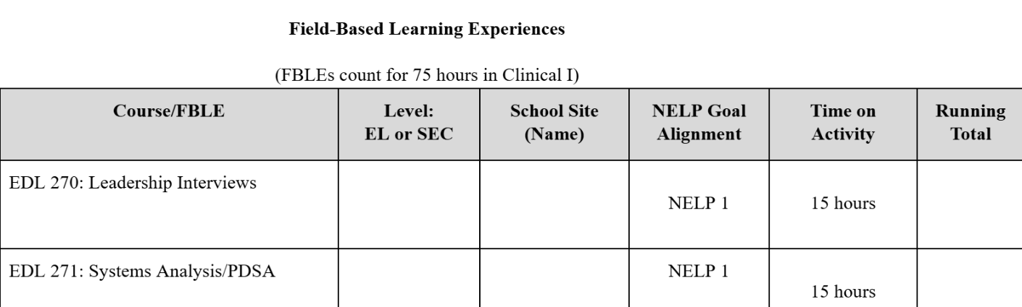

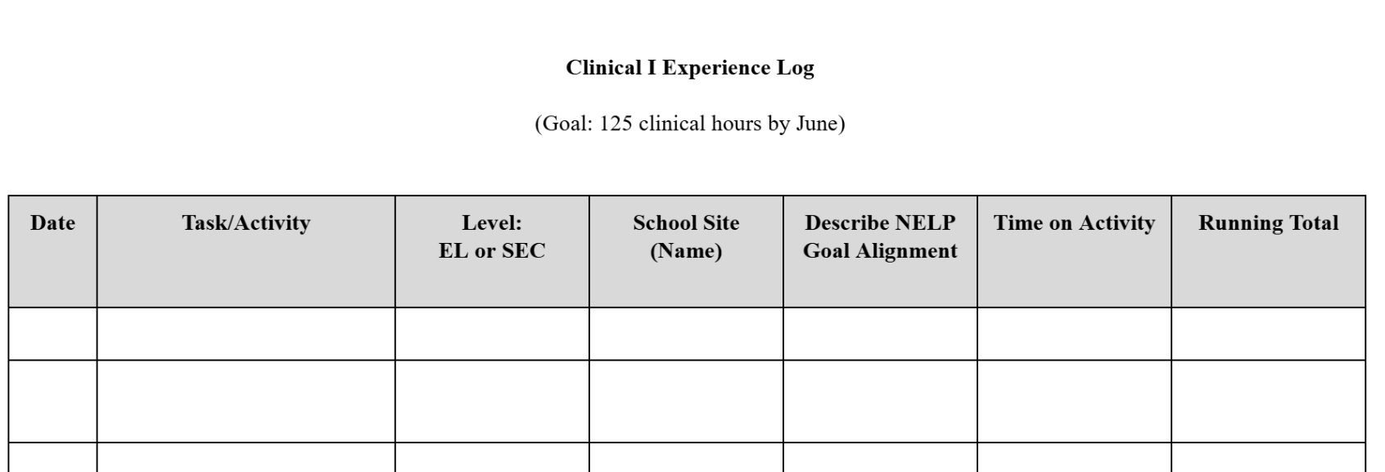

APPENDIX E – POSSIBLE CLINICAL ACTIVITIES FOR STUDENTS
Clinical Hours: List of potential clinical activities by NELP standard area
NELP 1 | Possible Activities:  School Board Meetings  District Executive Cabinet Meetings/Central Office  Administrative Meetings (Building Level)  Book Study  Community Forums around District/School Vision  School Advisory Council Meetings  Building Professional Development (taking a leadership role)  District Professional Development (taking a leadership role)  School/District Handbooks (employee, student, etc.)  School Improvement Planning  Tier 1 Teams  Building Leadership Team  Onboarding New Staff (taking a leadership role)  Welcoming New Students/Families (taking a leadership role)
NELP 2 | Possible Activities:  *Ethics and professional norms – Work with cohort to develop ideas aligned to this standard
NELP 3 | Possible Activities:  Creating an SEL program to implement at school  Working with SEL team (social-emotional learning)  School events to celebrate school culture and student success; Family Nights  Develop culturally responsive professional learning and growth opportunities  Analyzing data with an equity lens  IEP Meetings  504 Meetings  Child Study Team Meetings  Selecting curriculum and instructional materials (using an equity lens)  Safe Schools Committee  EL/ML leadership activities (multi-language learners)  Student voice, student leadership opportunities
NELP 4 | Possible Activities:  Shadow/observe instructional coach  Analyzing building/district instructional vision  Classroom “walkthroughs” and observations with administration or instructional coach  (instructional rounds, etc. monitoring teaching and learning in the school/district)  Curriculum review activities (taking a leadership role)  Professional learning community (PLC) meetings (taking a leadership role or observing PLCs outside of your own)  Learning management system support  Designing common formative assessments (outside of your own area, leadership role)  Implementation of standards-based grading (outside of your own practice)  Professional learning (taking a leadership role)  MTSS (multi-tiered systems of support) meetings (outside of your expected role)

NELP 5 | Possible Activities:  School Advisory Council Meetings  Parent-Teacher Association Meetings  Family Nights (taking a leadership role)  Book Study  Leadership on volunteer committees at the school  21st Century/After-school programming (observations of, leadership on)  School-based systems of support (food pantry, school culture, community outreach)  Advocacy of schools and education (letters to the editor, etc.)  Monitor or supervise after school activities  Shadow or observe or interview the Activities Director
NELP 6 | Possible Activities:  Systems related to walkthrough data: providing asset-based feedback, how to engage in instructional planning, analyzing walkthrough data (and other data) to determine team professional learning needs, etc.  Systems related to progress monitoring data: how to analyze data to drive instruction, how to analyze data trends to drive further professional learning, etc.  Continuing to align on what high-quality SDI looks like, including important background knowledge in order to engage in high-quality instructional planning  Continuing to get more specific about the assessments and curricular resources that can be leveraged to support students who are still struggling with word recognition/decoding - and foundational math skills - at the high school level  Collaborating with general education stakeholders to find ways to equip general education teachers with the tools they need to provide more accessible instruction to all students at Tier 1  Determining next steps with better ways to monitor, improve resources/supports for, and drive improvement in co-teaching spaces, self-contained spaces, and reverse consultation spaces
NELP 7 | Possible Activities:  During professional development, leverage inquiry activities, discussion activities, and protocols (including from “Tool Time”) to help build independent, critical thinkers who have space to begin to create/refine their own personal visions  Use one-on-ones/coaching meetings with consultants to help them refine and implement their personal visions  Use data and monitoring processes in conjunction with the HS Special Education Director to monitor and reinforce these systems

APPENDIX F – FBLE COMMUNICATION TOOL
Drake University Educational Leadership FBLE Communication Tool

Student Name: | Clinical Mentor: | Advisor:
This tool is designed to facilitate communication between students and their mentors regarding Field-Based Learning Opportunities (FBLEs) from each of their courses. After completing an FBLE, please fill out this form and share it with your mentor to receive feedback.
Date | Course | FBLE Topic and Summary | NELP Standards | Mentor Feedback | Advisor Initials
 | EDL 270
 | EDL 271
 | EDL 272
 | EDL 273
 | EDL 274
 | EDL 275
 | EDL 276
 | EDL 277
 | EDL 278
 | EDL 279

APPENDIX G – MENTOR FEEDBACK

The clinical professor will request feedback from the mentor regarding the student’s progress at least once annually. The mentor will be asked to assess the student on their work towards proficiency on National Educational Leadership Preparation Standards. Mentor feedback will be kept confidential. If the mentor chooses, feedback will be shared with the student.

Mentors will provide a quantitative score on each NELP standard observed.

NELP 1 | NELP 2 | NELP 3 | NELP 4 | NELP 5 | NELP 6 | NELP 7
Mission, Vision, and Improvement | Ethics and Professional Norms | Equity, Inclusiveness, and Cultural Responsiveness | Learning and Instruction | Community and External Leadership | Operations and Management | Building Professional Capacity

Mentors can also share qualitative feedback. Sample questions might include:

- What is your overall impression of this student and their commitment to the clinical experience?

- What did you observe to be this student’s strongest leadership traits and talents?

- How would you describe this student’s rapport with staff, students, colleagues, and parents?

- Did you observe or detect any “red flags” or ethical concerns with this student?

- Do you see this student as a successful leader or administrator?

APPENDIX H – CLINICAL EXPERIENCE EVALUATION FORM
Student Name: Drake Clinical Professor:

Clinical Mentor Name:

School Assignment:

Clinical Mentor Signature: Date:

*Please note: Descriptions of each of the NELP District Standards and their components were reproduced, with permission from NPBEA. (2018). National Educational Leadership Preparation (NELP) Program Standards - District Level. Retrieved from: www.npbea.org.

NELP 1 | NELP 2 | NELP 3 | NELP 4 | NELP 5 | NELP 6 | NELP 7
Mission, Vision, and Improvement | Ethics and Professional Norms | Equity, Inclusiveness, and Cultural Responsiveness | Learning and Instruction | Community and External Leadership | Operations and Management | Building Professional Capacity

Professional Habits
(N-Not Observed 1-Does Not 2-Approaching 3-On Target 4-High Degree 5-Exceptional)
Professional habit | Midterm Mentor | Midterm Student | Midterm Supervisor | Final Mentor | Final Student | Final Supervisor
Integrity-Follows through, participates appropriately in class, finds inspiration/learning in others’ success, values a diversity of opinions/thoughts, hands in assignments on time/every time.
Growth mindset-Accepts feedback from instructors, lifelong learner, lead leader, moves forward after setbacks, takes risks, persists in the face of set-backs.
Collaboration-Attends all classes, accepts feedback from peers, active listener, works to ensure all members of a group have a voice, collegial, values the input of others.
Preparation-Thoroughly reads and prepares for class and assignments, high expectations for self and others, embraces challenges, learns from criticism.

